Staff Wellbeing Physical Activity Programme – Spring 2025

Week Commencing 28th April 2025

The Staff Wellbeing Physical Activity Programme will return for Winter on week 28th April 2025.

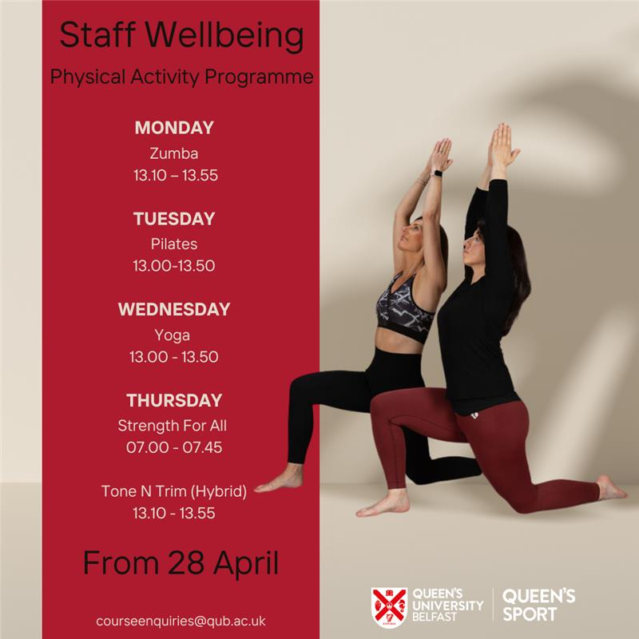

The programme details are below

Class | Day | Time | Studio | Instructor | Start date | Duration | Price
Zumba | Monday | 13.10 – 13.55 | PEC Studio 1 | Heather | 28th April to 23rd June | 7 Classes  *no classes on 5th May & 2nd June* | £35
Pilates | Tuesday | 13.00-13.50 | PEC Studio 3 | Asdis | 29th April to 24th June | 9 weeks | £45
Yoga | Wednesday | 13.00-13.50 | Studio 3 | Treasa | 30th April to 25th June | 9 weeks | £45
Strength for All | Thursday | 07.00 – 07.45 | PEC GTZ | Michael | 1st May to 19th June | 8 weeks | £48
Tone N Trim Hybrid | Thursday | 13.10 – 13.55 | Studio 1  & Online | Heather | 1st May to 26th June | 7 Classes  *no classes on 8th May & 5th June* | £35

Please note, places will be allocated on a first come, first serve basis.

- Zumba:- fuses aerobic, conditioning and dance training exercises to a mixture of Latin and International music. This is an exciting, high energy class which is suitable for all fitness levels. You will have so much fun, you won't believe it's a workout!
- Yoga:- you will be led through progressive Hatha Yoga with modifications for all. It will challenge & increase your strength & flexibility, while focusing on relaxation & mindfulness.
- Pilates:- for everyone wanting to build up core, back & glute strength with control & without impact. With moves that will focus on posture alignment & engagement of the muscles.
- Tone & Trim:- a progressive class using resistance and stretching exercises for precision firming and muscle conditioning, it provides an intense, non-cardio workout that targets all the major muscle groups. This class can be joined in person or online, depending on what best suits you that day.
- Strength for all:- Our Strength for all course will provide the perfect platform for you to achieve your fitness goals. This class includes using Dumbbells, Barbells & bodyweight to challenge all major muscle groups to become stronger.

If possible please bring your own exercise mat for the classes at Queen’s Sport

Changing Facilities and Showers are provided at Queen’s Sport..

Who are the classes suitable for? All ages/genders and levels of fitness, if you want to find out more about any of the sessions in advance of registering, please contact Course Enquiries at Queen’s Sport: courseenquiries@qub.ac.uk.

Registration and Payment: Booking and payment can be made via the online payment system here. You will be also asked to complete a short health questionnaire when making the payment. This must be completed before taking part in the classes.

You will receive an email confirming the venue for the classes the week before the classes begin. The link to the hybrid Tone N Trim classes will be circulated on 28th April 2025.

